IBM CLOUD ACCOUNT

TEAM LEADER: INDHUJA S

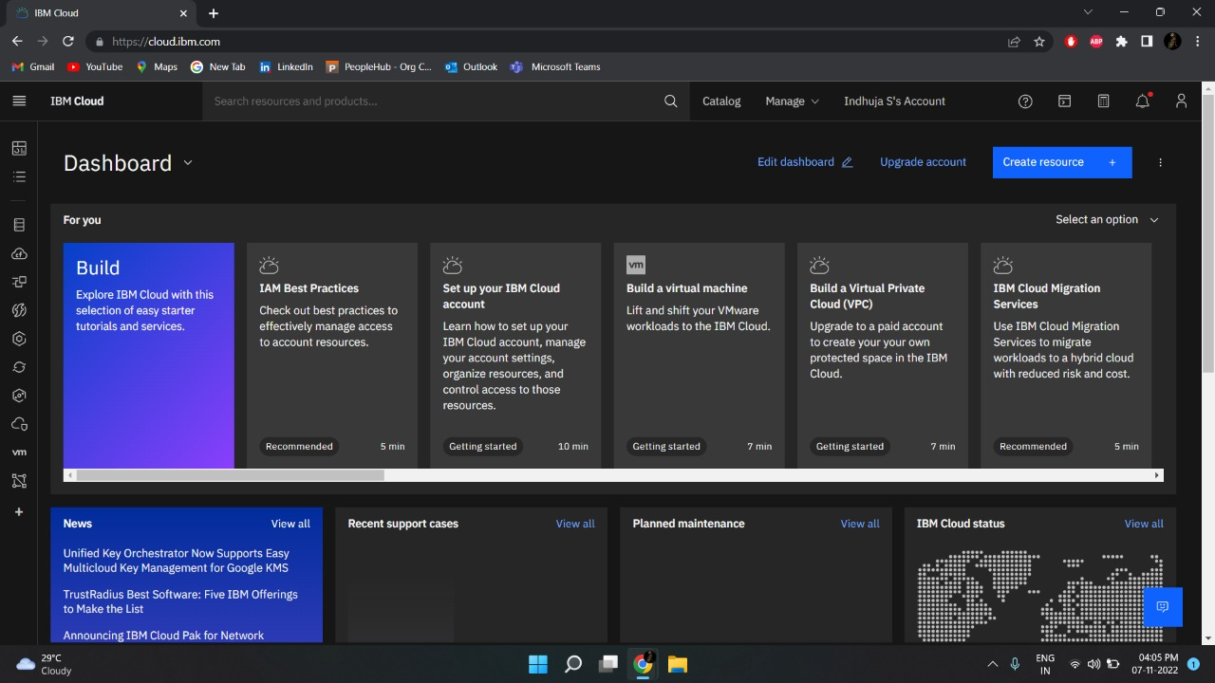

TEAM MEMBER 1: MUTHULAKSHMI M

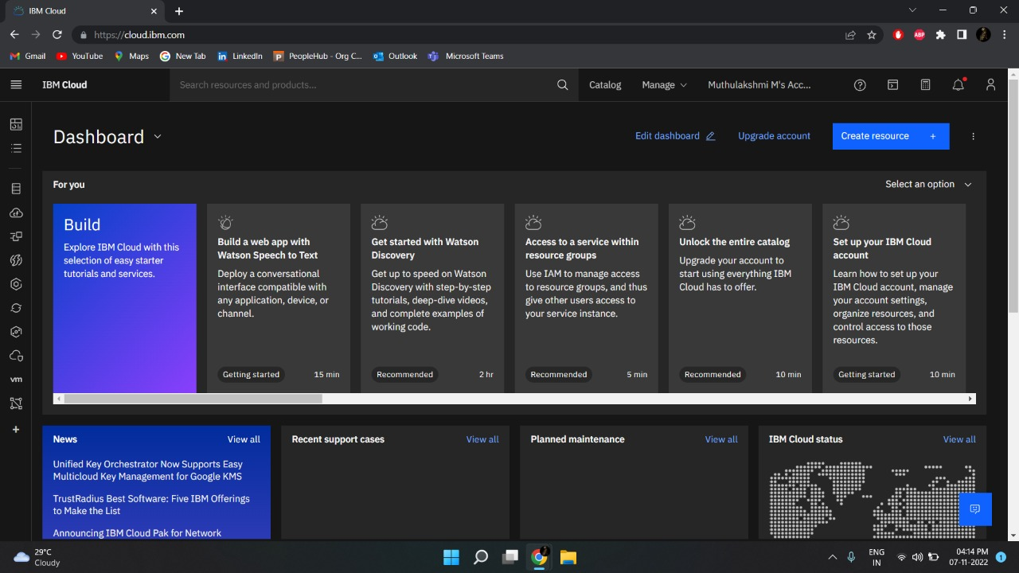

TEAM MEMBER 3: SUGASRI R

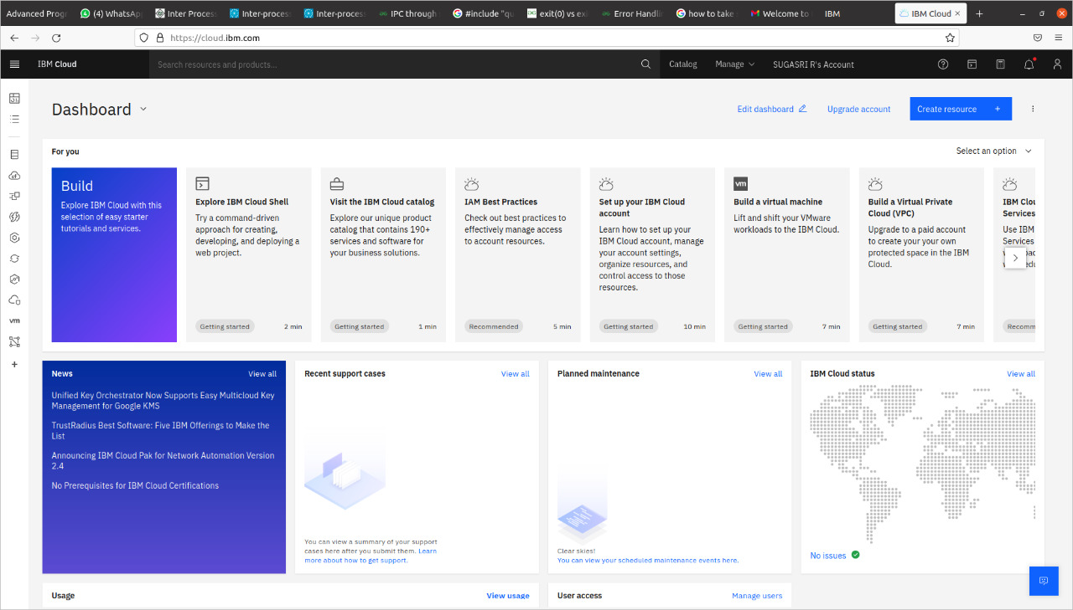

TEAM MEMBER 4: PRATHIKSHA B

